BLOOD
Hematopoiesis, the production from undifferentiated stem cells of circulating erythrocytes, platelets, and leukocytes, is a remarkable process that produces over 200 billion new blood cells per day in the normal person and even greater numbers of cells in people with conditions that cause loss or destruction of blood cells. The hematopoietic machinery resides primarily in the bone marrow in adults and requires a constant supply of three essential nutrients¾iron, vitamin B12, and folic acid¾as well as the presence of hematopoietic growth factors, proteins that regulate the proliferation and differentiation of hematopoietic cells.
Blood consists of:
■ red cells
■ white cells
■ platelets
■ plasma, in which the above elements are suspended.
Plasma is the liquid component of blood, which contains soluble fibrinogen. Serum is what remains after the formation of the fibrin clot.
Anaemia (Lack of blood) is a decrease in normal number of red blood cells or less than the normal quantity of hemoglobin in the blood.
Types of anemia: There are three major types:
  - Hypochromic microcytic with a low MCV (mean corpuscle/cell vol: RBCs) = < 80 Normochromic normocytic with a normal MCV = 80-100
  - Macrocytic with a high MCV = > 100
Clinical features
Patients with anaemia may be asymptomatic that is having no apparent symptom. Because as the level of Hbs fall slowly, it allows for haemodynamic compensation, that is increased production of RBCs and Hbs in response to decreased level of Hbs. This increase in Hbs further enhances the oxygen-carrying capacity of the blood and patients are usually asymptomatic although there is progressive fall in the level of Hbs.

Sign & symptoms of anemias (all non-specific)
  - Fatigue, headaches and faintness are all very common.
  - in the general population
    - Breathlessness
    - Angina
    - Intermittent claudication (impairment in walking)
    - Palpitations.
    - Pallor
    - Tachycardia
    - Systolic flow murmur
    - Cardiac failure
    - Brittle & spoon-shaped nails (Koilonychia)
    - Atrophy of the papillary of tongue
    - Angular stomatitis
    - Brittle hair &
    - Dysphagia and glottitis
Following table shows daily intake of iron
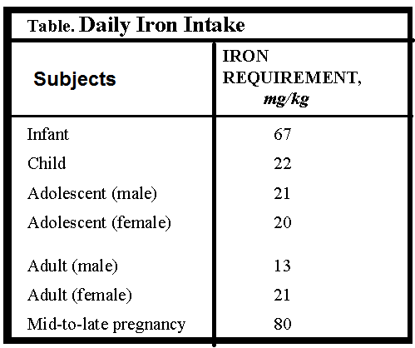

Pharmacology of antianemic drugs
Following are major classes of anti-anemic drugs;
1. Iron
2. Vitamin B12
3. Folic acid and
4. Hematopoietic growth factors, such as
  - Erythropoietin (epoetin alfa),
  - granulocyte colony-stimulating factor (G-CSF),
  - granulocyte-macrophage colony-stimulating factor (GM-CSF), and
  - interleukin-11 (IL-11)

Iron:
Iron is used for the treatment of iron deficiency anemia, which is characterized by
  - pallor,
  - fatigue,
  - dizziness,
  - exertional dyspnea, and
  - other generalized symptoms of tissue hypoxia.
- The cardiovascular adaptations to chronic anemia tachycardia, increased cardiac output, vasodilation can worsen the condition of patients with underlying cardiovascular disease.
- Iron forms the nucleus of the iron-porphyrin heme ring, which together with globin chains forms hemoglobin.
- Hemoglobin reversibly binds oxygen and provides the critical mechanism for oxygen delivery from the lungs to other tissues. In the absence of adequate iron, small erythrocytes with insufficient hemoglobin are formed, giving rise to microcytic hypochromic anemia.
- Iron deficiency can result from inadequate iron intake, malabsorption, blood loss, or an increased requirement, as with pregnancy.

